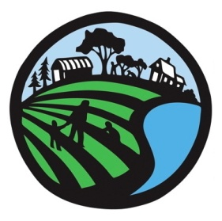**April 11 South of the Sound Community Farm Land Trust Agricultural Networking**

**Enterprise for Equity**

Enterprise for Equity is a non-profit organization that provides business training, technical assistance, market access and business counseling to people with limited incomes in Grays Harbor, Thurston, Lewis, Pacific and Mason Counties.   In addition to support for microenterprises with 5 or fewer employees, Enterprise for Equity launched their Agri-Preneurship Training Programs in 2009 in collaboration with WSU Extension specifically for food, fish and farm based businesses.  Enterprise for Equity also serves as a microlender and offers small loans up to $25,000 to launch small enterprises in the region who complete their programs.  Many small companies like Bear Foot Mobile Farm Equipment Repair (www.bearfootmobile.com), Olykraut, Nineveh, Calliope Farm and Healthy Benefits Market in Shelton have all completed Enterprise for Equity’s business training programs.   Over the last several years Enterprise for Equity has had significant collaboration with the Thurston Conservation District, South of the Sound Community Farm Land Trust, USDA, WSU Extension, Economic Development Councils in the region to advance local sustainable farm initiatives.

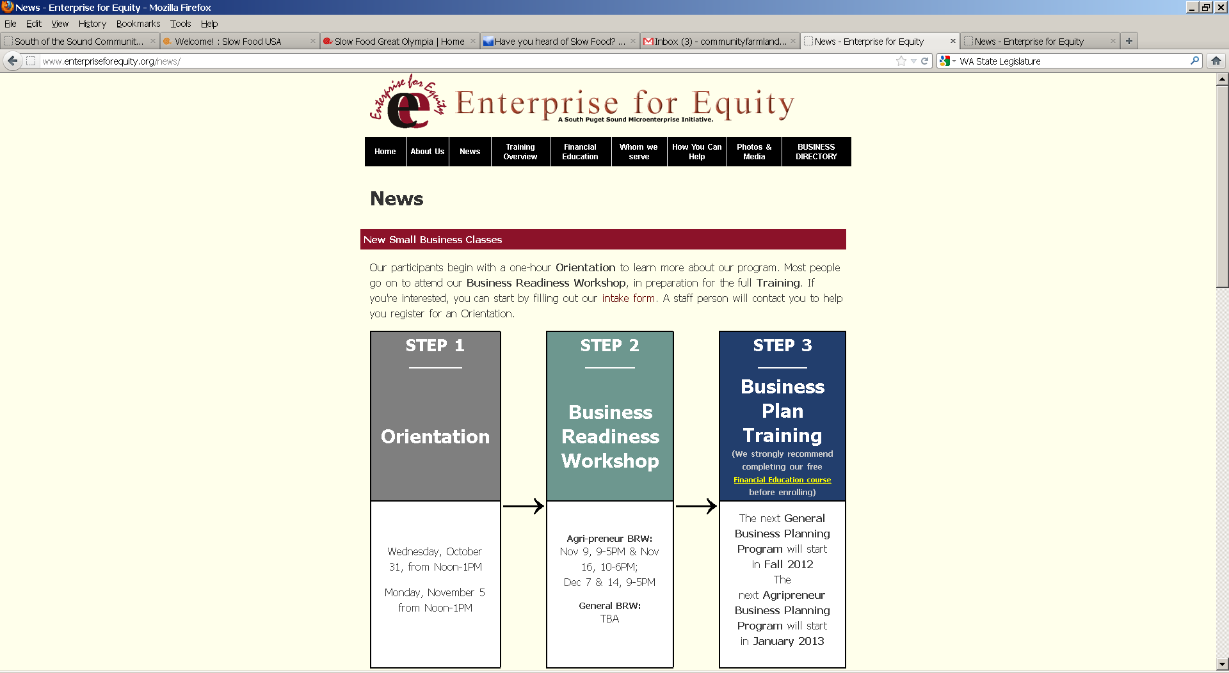

Lisa Smith, Executive Director

Enterprise for Equity

[www.enterpriseforequity.org](http://www.enterpriseforequity.org)

(360) 704-3375

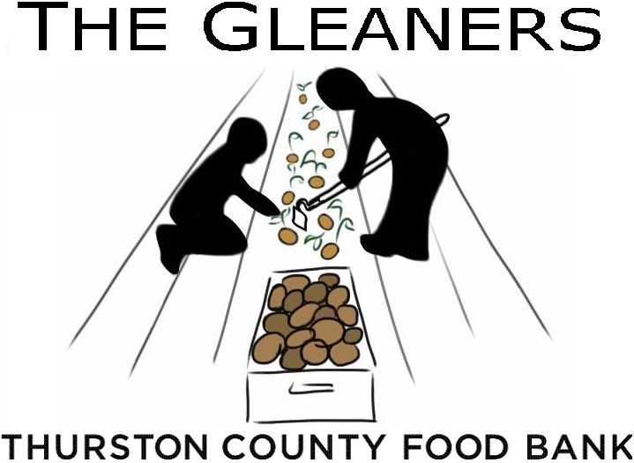**Gleaning Program, Thurston County Food Bank**

Thurston County Food Bank’s gleaning program works with community volunteers to harvest surplus produce from local farms. Since its inception in 2009, the TCFB Gleaners have harvested over 105,000 pounds of fresh fruit and vegetables for our neighbors in need.

Heather Sundean, Produce Manager

Thurston County Food Bank

(360) 352-8597 Ext. 105

[produce@thurstoncountyfoodbank.org](mailto:produce@thurstoncountyfoodbank.org)

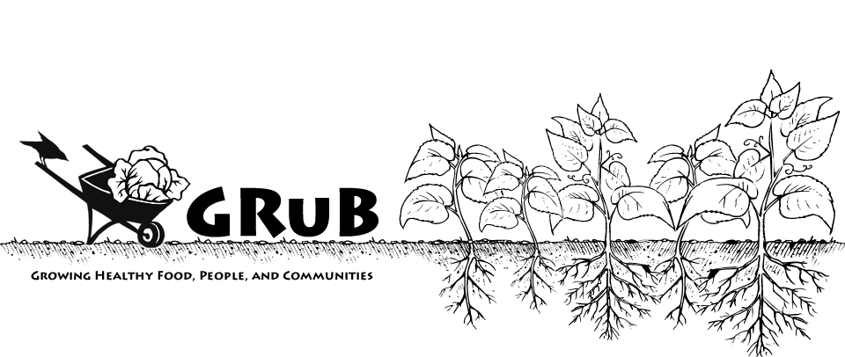**GRuB (Garden-Raised Bounty)**

GRuB inspires positive personal and community change by bringing people together around food and agriculture. We partner with youth and people with low-incomes to create empowering individual & community food solutions. We offer tools & trainings to help build a just & sustainable food system.  
  
GRuB (Garden-Raised Bounty)  
2016 Elliott Ave NW  
Olympia, WA 98502  
(360) 753-5522 -<http://goodgrub.org> for more information

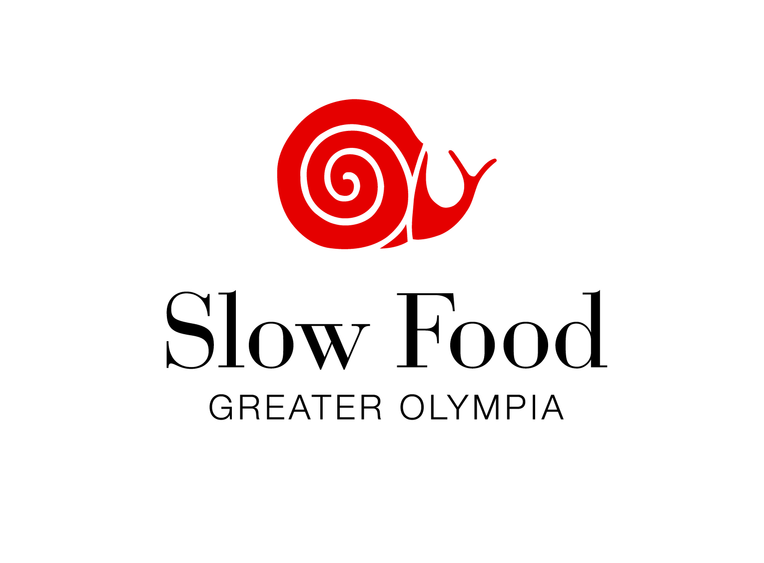

**Slow Food Greater Olympia**

Slow Food is an idea, a way of living and a way of eating. It is a global, grassroots movement with thousands of members around the world that links the pleasure of food with a commitment to community and the environment. We advocate sustainability and bio-diversity through educational events and public outreach that promote the appreciation and consumption of seasonal and local foods and the support of those who produce them. We believe the food we eat should taste good; it should be produced in a clean way that does not harm the environment, animal welfare, or human health; and its producers should receive fair compensation for their work.

GOslowFood@gmail.com -<http://slowfoodolympia.org/>

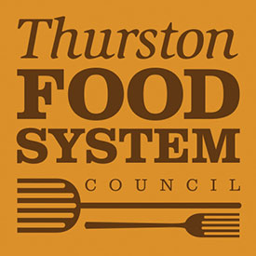**Thurston Food System Council**

The Thurston Food System Council is a grassroots citizens organization composed of a diverse group of community stakeholders empowered by the community and recognized by local government to foster collaboration and active engagement in the local food system. Our Mission: To bring together the community resources, people and programs to develop and strengthen the local food system..

Sash Sunday, Chair

<http://thurstonfoodcouncil.org/>

[tfsc0@yahoo.com](tfsc0@yahoo.com%20)

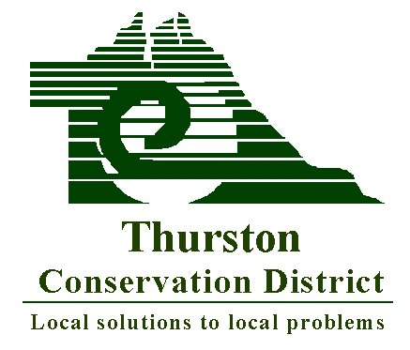

**Thurston Conservation District**

Thurston Conservation District promotes voluntary stewardship among private landowners in Thurston County. We are a non-regulatory organization that offers many services to our residents, including: equipment rentals (poultry processor; manure, drop and spin spreaders; weed wrenches and other hand tools), soil testing, technical assistance and conservation planning. Our Resource Specialists are available for free site visits to address natural resource concerns or questions including: livestock care, pasture management, noxious weed control, plant I.D. and planting plans, erosion control, storm water issues, nutrient management and more! We also offer a variety of educational programs for landowners, including: free hands-on and how-to workshops, on the ground tours for farmers and the community, student watershed education programs, resources for landowner funding and assistance programs, salmon recovery and great volunteer and internship opportunities! In addition, we now offer the South Sound FarmLink program that connects new and expanding farmers with landowners who are interested in leasing or selling farmland in our community! Interested farmers or landowners should visit: [www.ThurstonCD.com/farm-lease](http://www.ThurstonCD.com/farm-lease)

Stay in touch for great information: [www.ThurstonCD.com](http://www.ThurstonCD.com)  or follow us on Facebook [facebook.com/thurstoncd](http://facebook.com/thurstoncd)) and Twitter (@ThustonCD)!  2918 Ferguson ST SW, STE A, Tumwater WA 98512     [(360) 754.3588](tel:%28360%29%20754.3588)

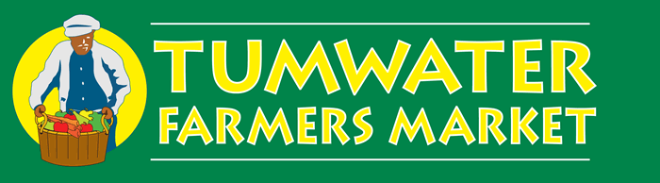**Tumwater Farmers Market**

Since 2006, the Tumwater Farmers Market has been bringing together producers and consumers in a congenial atmosphere that promotes the economic well-being of local agriculture, the nutritional well-being of consumers and the social health and wealth of local communities. Consumers will find a colorful array of fruits, vegetables, flowers, plants, baked goods and prepared foods to meet their lunchtime shopping and dining needs and desires. A unique feature of the market will be a community booth, open to local nonprofits, state agencies, labor and civic organizations on a rotating basis for information sharing and community outreach. The Tumwater Farmers Market is located on the southwest corner of Capitol Boulevard and Israel Road, directly behind the city’s maintenance and facilities building and is open every Wednesday June through October, from 11 a.m. to 2 p.m.

360.464.5879 -manager@tumwaterfarmersmarket.org

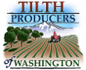**Tilth Producers of Washington**

Tilth Producers promotes ecologically sound, economically viable and socially equitable farming practices that improve the health of our communities and natural environment. Tilth Producers is a state-wide nonprofit organization that promotes ecologically sound, economically viable and socially equitable farming practices that improve the health of our communities and natural environment. Tilth Producers offers farmers: an annual conference, 12+ farmwalks each year, a quarterly journal, policy and advocacy work, and online classifieds and internship listings.

206-632-7506 [http://tilthproducers.org/](http://tilthproducers.org/%20) Local Board members:

Addie Candbid - addie.candib@gmail.com 360-866-6395

**West Olympia Farmers Market**

The West Olympia Farmers' Market is a small neighborhood farmers' market committed to supporting the local food economy and providing marketing opportunities for the many beginning and young small farmers of Olympia and the South Sound. We have all your favorite farmers' market treats and are always looking for more vendors. Please join us for our 3rd season, Tuesdays from 4 to 7PM at Gloria Dei Lutheran Church on Harrison Ave and Thomas St starting May 14th, 2013.

For more information about the market and vending opportunities, check out our website at [wolyfarmersmarket.org](http://wolyfarmersmarket.org) or email Kayla Mahnke, market manager, [wolyfarmersmarket@gmail.com](mailto:wolyfarmersmarket@gmail.com)

Facebook: <http://www.facebook.com/wolyfarmersmarket>

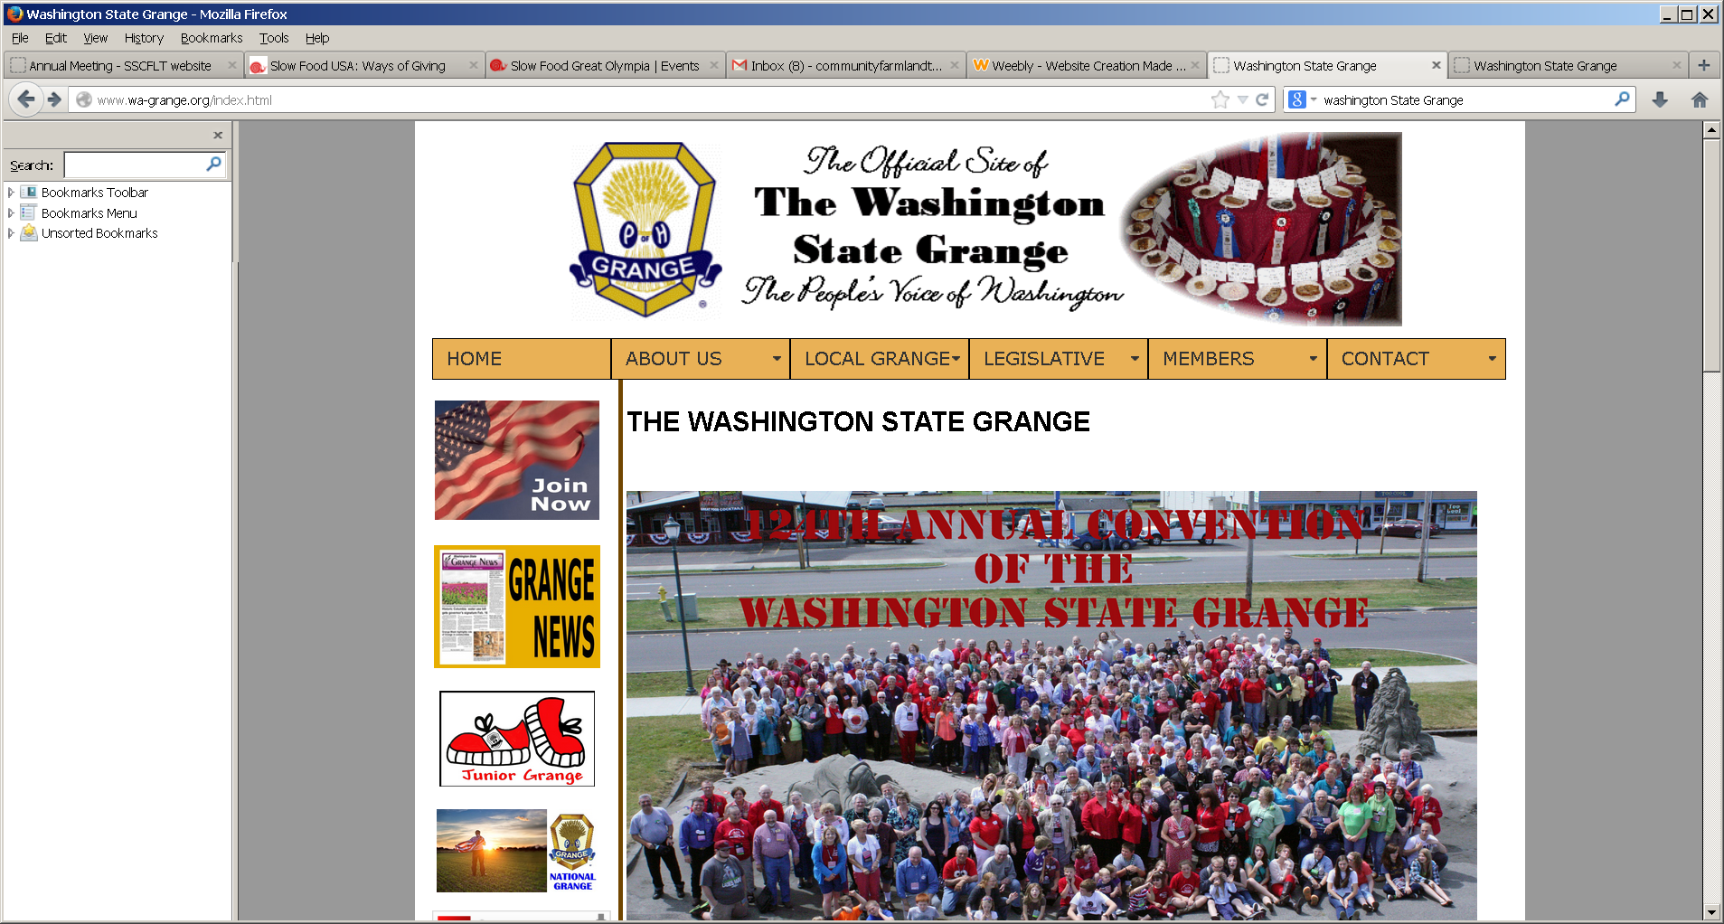**Washington State Grange**

The Grange is America's oldest farm-based fraternal organization. We are a non-partisan, grassroots advocacy group for rural citizens with both legislative programs and community activities such as talent and craft contests, scholarships, youth programs and camps, and much more. The Grange advocate for all Americans, especially those under-represented residents of our farms, small towns and rural areas.

Rusty Hunt, Membership Director

[membership@wa-grange.org](membership@wa-grange.org%20)

[**http://www.wa-grange.org/**](http://www.wa-grange.org/)

**WSU Thurston County Extension**

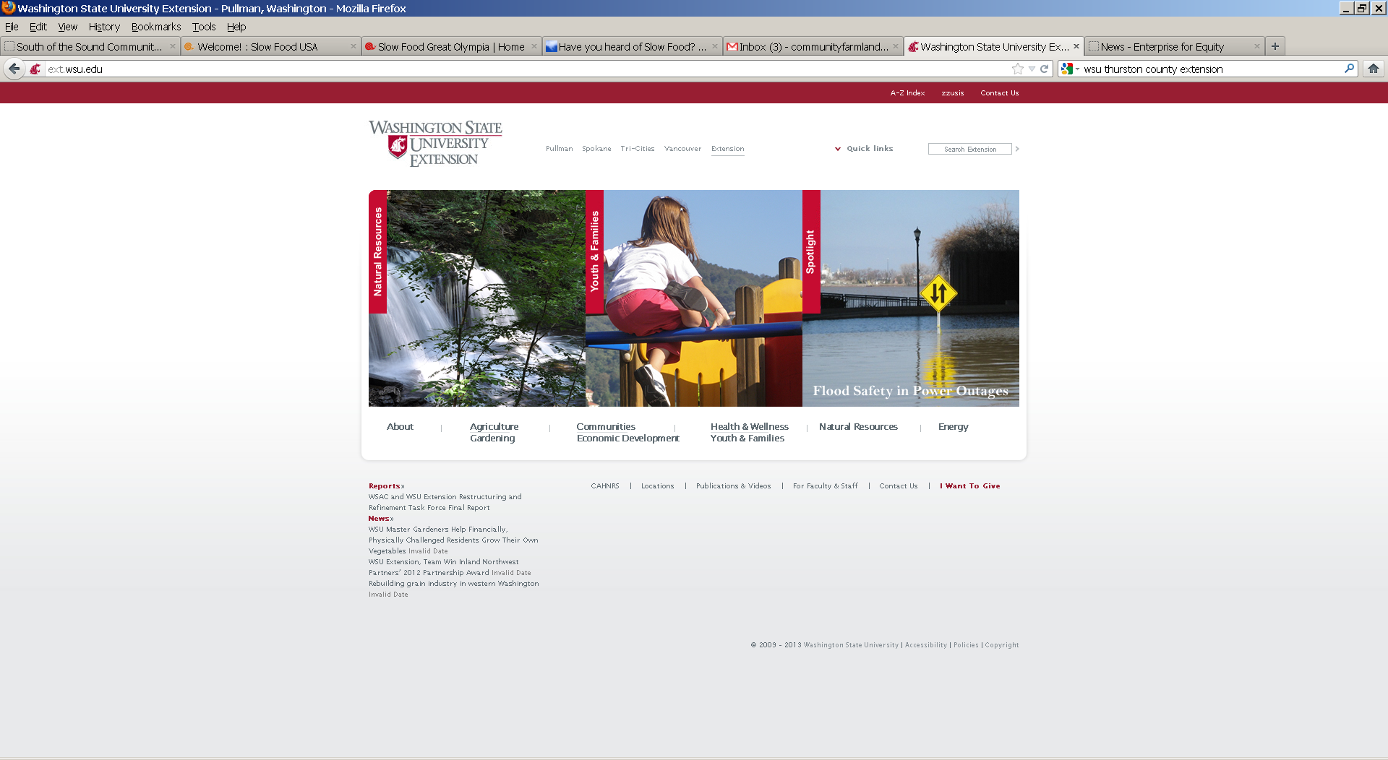Washington State University (WSU) Thurston County Extension connects the people of Thurston County to the research and knowledge bases of the state's land grant research university, and the land grant universities of other states, to provide solutions to local problems and bolster the local economy.  Our county-based educators work with partners in the community to provide educational programs for all age groups, and to leverage the broad resources of WSU to resolve issues and create a positive future for the residents of Thurston County.

Check the website for a calendar of events of interest in the farm community.

WSU Thurston County Extension

5033 Harrison Ave NW

Olympia, WA 98502 -360.867.2151

<http://county.wsu.edu/thurston/Pages/default.aspx>

**WSU Thurston County 4-H**

WSU Thurston County 4-H provides a wide variety of activities for youth in grades kindergarten through twelve. **4-H** members "learn by doing." Through hands-on learning experiences, youth members, with guidance from adult volunteers, learn useful skills they can use throughout their lifetime. **The Thurston County 4-H Office is open:** Mondays & Thursdays 9 AM to 1 PM, Wednesdays & Fridays Noon to 4 PM, Closed Tuesdays

WSU Thurston County 4-H

5033 Harrison Ave NW

Olympia, WA 98502 -360.867.2151

<http://county.wsu.edu/thurston/youth/Pages/default.aspx>

**Yelm Farmers Market**

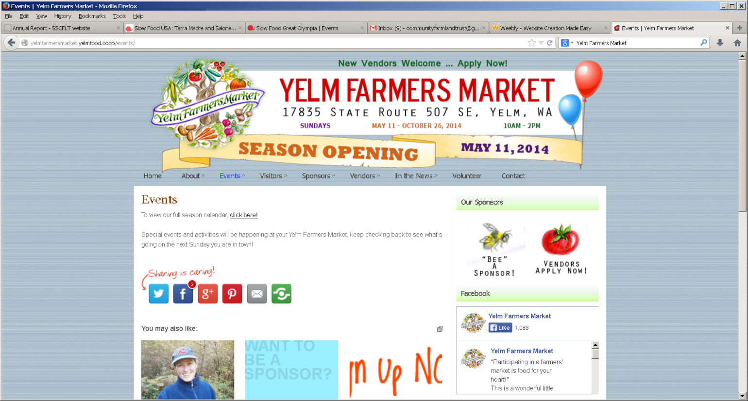The Yelm Farmers Market was developed by the Yelm Food Cooperative in 2012 in response to the growing demand in the Yelm area for a market to support local growers and make farm fresh foods more widely available to the community.  This year's market runs every Sunday from 11th May until 26th October and is situated just outside the city limits on the beautiful Nisqually Springs Farm.  We are looking for a wide array of vendors to join us and invite local farmers and artisans to contact the market manager for more details on how to be part of this burgeoning farmers market.

Contact Karen - [yelmfarmersmarket@gmail.com](mailto:yelmfarmersmarket@gmail.com)  [(360)-894-1164](tel:%28360%29-894-1164)